TEST RESULT
- OQ-TC-02: Limit File Dependency Verification (Missing File)
Objective:
To confirm the system blocks analysis if the configuration file (`SetPointLimit.xlsx`) is missing.
Procedure:
- Navigate to the application root directory.
- Open the AQR application
- Select analyze required CSVs files.
- Observe the 'Analyze' button.
Acceptance Criteria:
- The system displays an error message: "ERR-002: Limit File Not Found".
- The 'Analyze' functionality is disabled.
Results:
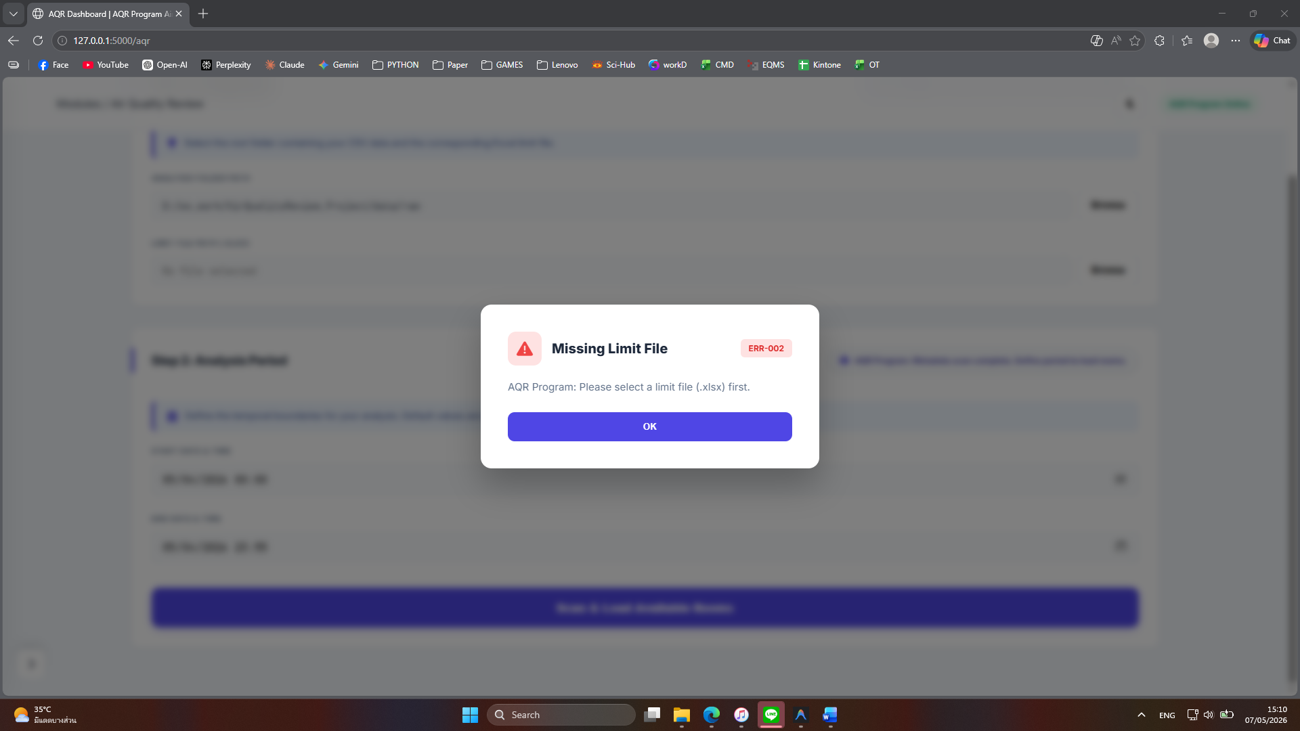

- OQ-TC-03: Limit File Integrity (Invalid Data/NaN Handling)
Objective:
To verify the system handles non-numeric limit values in the Excel file without crashing.
Procedure:
- Open `SetPointLimit.xlsx` using Microsoft Excel.
- In the "Temperature High Limit" cell, delete the value and type "NOT_A_NUMBER".
- Save the file and attempt to run an analysis in the AQR application.
Acceptance Criteria:
The system stops the process and displays: "ERR-003: Invalid Configuration - High Limit must be a number".
Results:
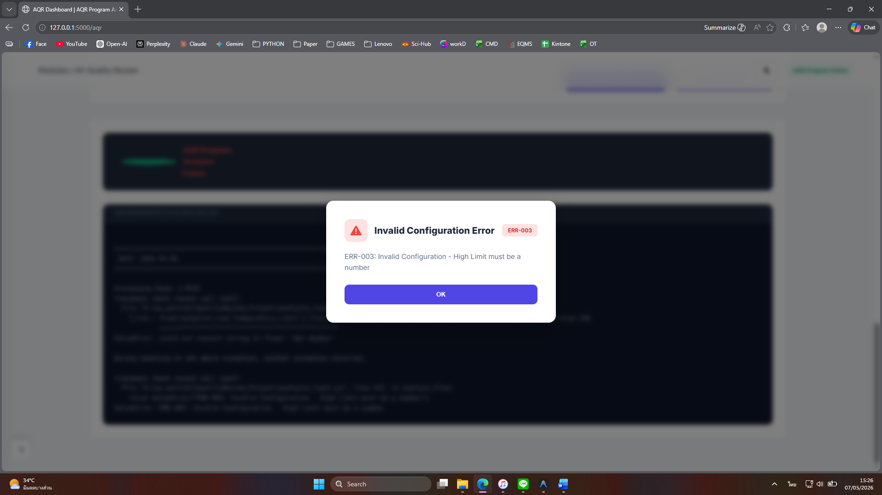
- OQ-TC-19: Invalid CSV Header/Column Verification
Objective:
To verify that the system rejects files with incorrect or missing column headers.
Procedure:
- Select a CSV file and change / delete the column header “<>Date”, “Time”, “Point_1”, “Point_2”, “Point_3”.
- Attempt to process this file in the AQR application.
Acceptance Criteria:
The system displays an error: "ERR-005: Invalid File Format - Required columns not found."
Results:
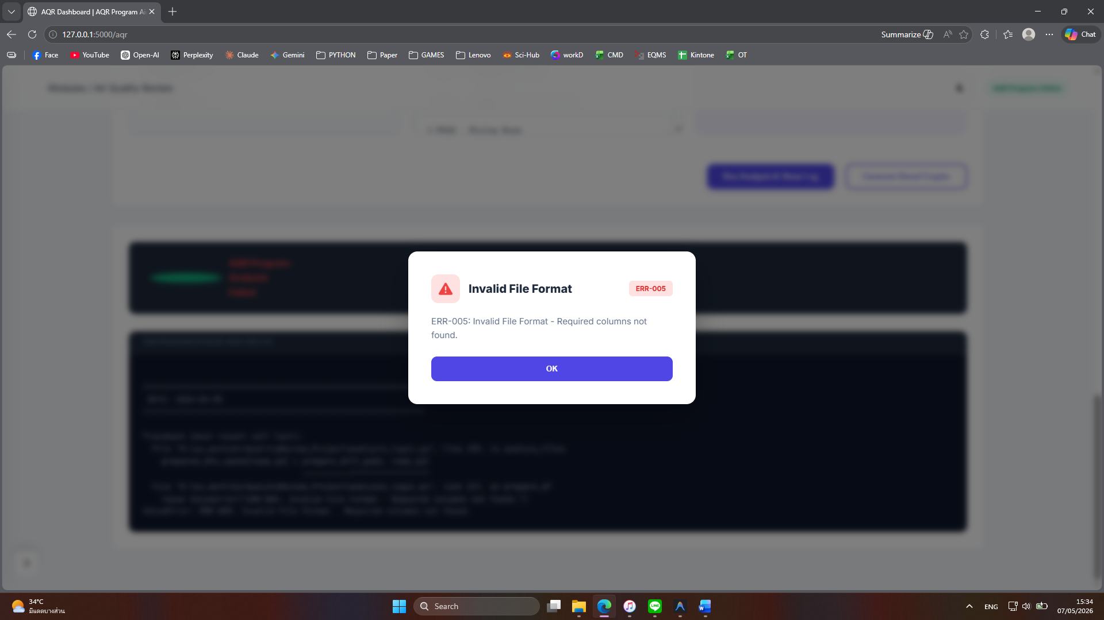
- OQ-TC-24: Source File Traceability (SHA-256 Generation)
Objective:
To confirm that every data file (CSV) analyzed by the system creates a unique digital fingerprint in the audit log. To trust the final report, we must prove it came from a specific, original file that has not been changed. A SHA-256 hash is like a "digital fingerprint." If the file changes by even one byte, the fingerprint changes completely.
Procedure:
- Launch the `AirQualityReview.exe` application.
- Click the 'Select File' button and choose a valid CSV data file.
- Click the 'Analyze' button and wait for the process to complete.
- Navigate to the `./logs/` directory and open `audit_trail.log` with Notepad.
- Search for the most recent entry labeled `[FILE_PROCESSED]`.
Acceptance Criteria:
- The log entry contains the full name of the processed file.
- The log entry contains a unique 64-character SHA-256 hash string.
Results:
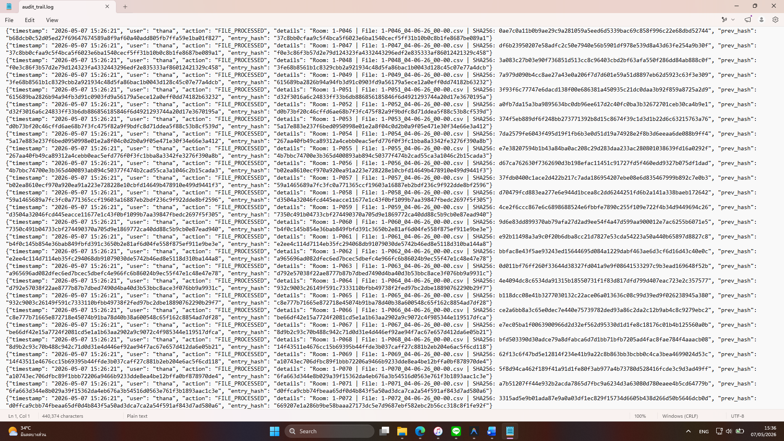
- IQ-TC-06: Standalone Isolation Verification
Objective:
To mathematically prove that the application is fully independent. It must be capable of executing all its core functions without relying on external internet connections or pre-installed programming software (like Python) on the user's computer.
Procedure:
- Network Isolation:
- Disable all internet and network connections on the workstation (Wi-Fi, Ethernet).
- Confirm the system is completely offline.
- Environment Verification (No Python Installed):
- Press `Windows + R`, type `cmd`, and press Enter.
- In the Command Prompt, type `python --version` and press Enter.
- Verify that the system returns an error message stating that 'python' is not recognized.
- Application Execution:
- Navigate to the application directory and double-click `AirQualityReview.exe`.
- Interface Accessibility:
- Open a standard web browser (like Edge or Chrome).
- Enter the address `http://127.0.0.1:5000` in the address bar.
Acceptance Criteria:
- The application launches successfully in a completely offline environment.
- The visual dashboard is fully accessible and functional through the local network port.
Results:
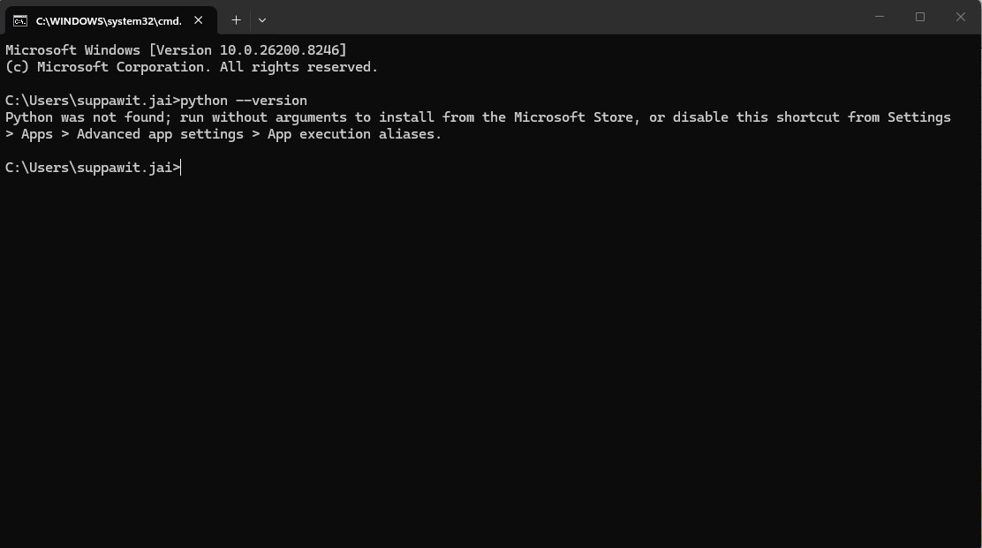
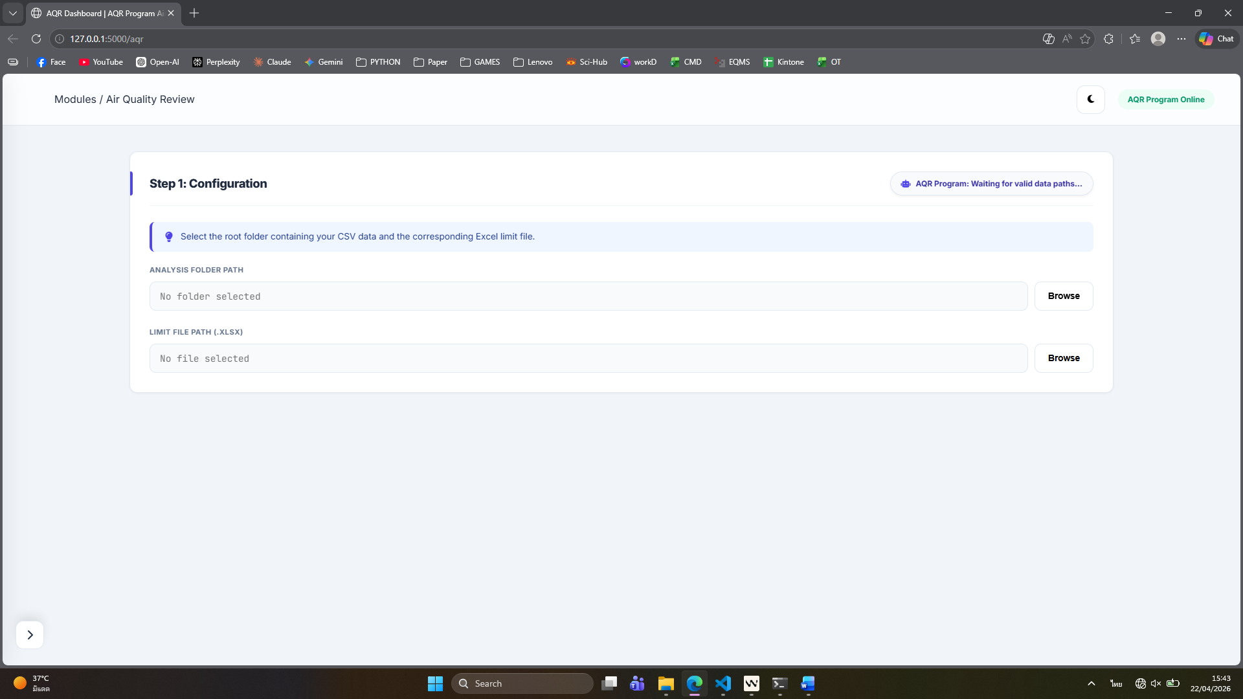
- OQ-TC-23: Audit Trail Hash-Chain Tamper Detection
Objective:
To verify that the system detects unauthorized modifications to the `audit_trail.log` file and halts execution. According to regulatory rules (21 CFR Part 11), electronic records must be protected from manual changes. The system uses a "hash-chain" where each line of text is linked to the previous one mathematically. If even one letter is changed, the link breaks. This ensures that no one has edited the history of what the system did.
Procedure:
Open Windows File Explorer and navigate to the application root directory.
- Enter the `./logs/` folder.
- Right-click the `audit_trail.log` file and select 'Open with Notepad'.
- Scroll to the end of the file, locate any long string of random characters (the "hash"), and delete or change a single character in that string.
- Click File > Save and close Notepad.
- Return to the application root directory and double-click `AirQualityReview.exe` to launch the application.
Acceptance Criteria:
- The application must not open the main dashboard.
- A popup window or console message appears with the exact text: "FATAL ERROR 004: Audit Trail Integrity Check Failed"
Results:
